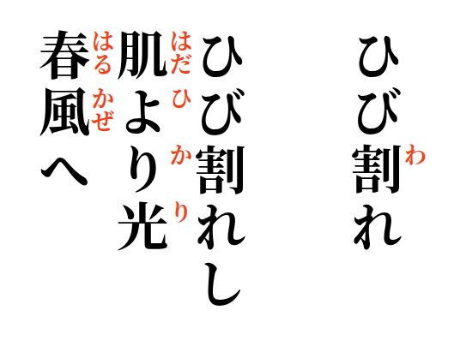

2026-09-28
Cracked skin

Cracked skin cannot hold
the light beneath it escapes
into the spring air

